Analog Portable Graphic Equalizer

Antonio Cardona

Nathan Finley

Nicole LoGiudice

**Concept of Operations**

REVISION – Draft

08 September 2022

Concept of Operations

for

Analog Portable Graphic Equalizer

Team GrAPE

Approved by:

_____________________________

Project Leader Date

_____________________________

Prof. Kalafatis Date

_____________________________

T/A Date

**Change Record**

|  |  |  |  |  |
| --- | --- | --- | --- | --- |
| **Rev.** | **Date** | **Originator** | **Approvals** | **Description** |
| **-** | 09/13/22 | Nicole LoGiudice  Antonio Cardona  Nathan Finley |  | Draft Release |

Table of Contents

Table of Contents III

List of Figures IV

1. Executive Summary 1

2. Introduction 2

2.1. Background 2

2.2. Overview 2

2.3. Referenced Documents and Standards 3

3. Operating Concept 4

3.1. Scope 4

3.2. Operational Description and Constraints 4

3.3. System Description 5

3.4. Modes of Operations 5

3.5. Users 5

3.6. Support 5

4. Scenario(s) 6

4.1. Power Sourcing and User Interface 6

4.2. Main Signal Processing 6

4.3. Housing and Bluetooth Input/Output Connectivity 6

5. Analysis 6

5.1. Summary of Proposed Improvements 6

5.2. Disadvantages and Limitations 6

5.3. Alternatives 7

5.4. Impact 7

List of Figures

Figure 1: Analog Portable Graphic Equalizer Block Diagram 3

# Executive Summary

During events or large gatherings, the use of audio processing devices such as equalizers is typically used to provide quality audio entertainment. Frequently, equalizers have installed applications and often receive and deliver audio signals through wired connections. The GrAPE (graphic analog portable equalizer) differs from typical analog equalizers by the main features being audio signal processing via Bluetooth and its portability. The GrAPE will be a graphic analog portable equalizer that will consist of at least ten frequency bands between 0Hz to 20kHz. The gain of these frequency bands will be adjusted with the help of sliders physically on the device. The input and outputs for the GrAPE will operate via Bluetooth with the additional ability to use an auxiliary connection at the output. The size of the GrAPE will be designed to be small enough to fit into small carriers, such as backpacks. The goal of the GrAPE is to provide its users with a low-budget quality audio processor that provides portability and accessibility.

# Introduction

This document is an introduction to the GrAPE, a graphic analog portable equalizer, that will provide its users with a low-budget quality audio processing system. The graphic equalizer will serve as a tool to enhance the performance of an audio system by controlling the gain of various frequency bands, which are physically displayed on the device with sliders. The input and outputs of the graphic equalizer will function via Bluetooth with the additional feature of having an auxiliary connection at the output stage of the device.

## Background

Equalizers are audio processing devices that are widely used in audio systems. The use of equalizers has become standard in modern audio applications; whereas before, equalizers were used mostly in telephones to enhance the intelligibility of the speech signal in the 1930s by flattening out the audio response [1]. However, equalizers are used today to enhance the performance of the system by allowing one to choose whether to increase or decrease chosen frequency gains, rather than just flattening.

There are two main types of equalizers: parametric and graphic. Parametric equalizers allow the user to control the gain, center frequency, and bandwidth of the equalizer filters separately. These equalizers are known for being flexible due to the number of factors a user can control. However, the knowledge level needed to efficiently utilize parametric equalizers is high, therefore experts and engineers mostly utilize these types of equalizers. Graphic equalizers, on the other hand, allow the user to control the gain of various frequency bands, while the center frequency and the bandwidth are fixed, leaving the user to only control the gain of a specific frequency band. Since graphic equalizers are less intricate and require less training than parametric equalizers, they are used more frequently by the general public.

Graphic equalizers are generally built to be used through installed applications and typically are not portable. In addition, the input and output of the most common graphic equalizers are completely analog instead of wireless. This is where the GrAPE differs from typical equalizers; as the GrAPE will be built to be portable, and the input/output will operate via Bluetooth with the option of an auxiliary connection at the output. The GrAPE is set to provide its users with a relatively low-budget quality audio processing device that is portable and accessible.

## Overview

The system for the analog portable graphic equalizer will operate with a single input from a smartphone device via Bluetooth receiver and a dual output: Bluetooth transmitter and auxiliary. The GrAPE will require two microcontrollers:  digital-to-analog (DAC) and analog-to-digital (ADC). The GrAPE user interface includes a set of at least ten sliders on the housing. The main signal processor, as seen in Figure 1, will set the frequency bandwidths; then, for each bandwidth, it will alter the gain to the desired level and fix each frequency center.

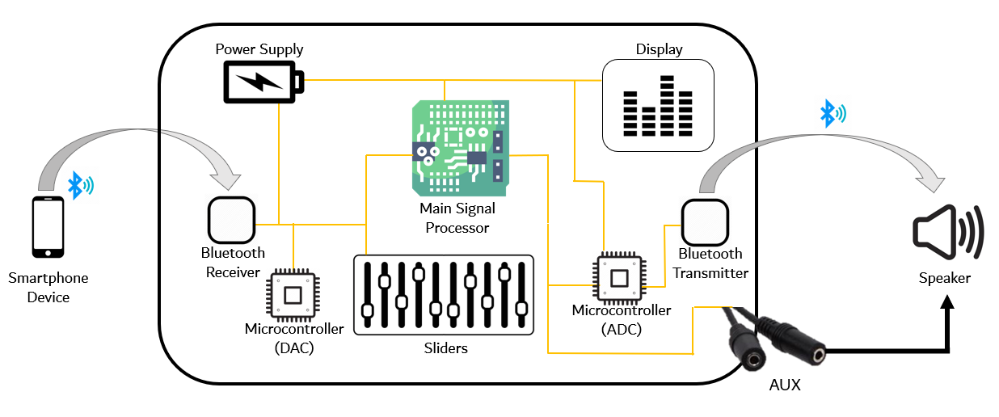

*Figure 1: Analog Portable Graphic Equalizer Block Diagram*

## Referenced Documents and Standards

[1] J. Rämö, V. Välimäki and B. Bank, "High-Precision Parallel Graphic Equalizer," in IEEE/ACM Transactions on Audio, Speech, and Language Processing, vol. 22, no. 12, pp. 1894-1904, Dec. 2014, doi: 10.1109/TASLP.2014.2354241.

# Operating Concept

## Scope

The Graphic Analog Portable Equalizer will operate as a standard analog equalizer with at least ten frequency-tuning sliders, an attached display to visualize frequency strengths, Bluetooth input, and output connectivity, and an internal power source. The above functionality will fit inside an enclosure no larger than the capacity of a backpack. A continuous phone-transmitted Bluetooth signal containing audio data will be received, manipulated as per the settings of the frequency sliders, and then transmitted to any device for playback (via Bluetooth or auxiliary). Signal processing and transmission will be designed to occur concurrently with signal reception and latency will be minimized so that the GrAPE can tune “live” music and a user needn’t wait a significant time for playback. Though the current market has plenty of analog equalizer equipment to choose from, the additional display and Bluetooth features distinguish the GrAPE as a device that could benefit users who desire frequency-tuned audio but require wireless transmission.

## Operational Description and Constraints

The GrAPE is purely an audio modification and transmission device. The Bluetooth connectivity allows for one transmission device, a phone; and two reception devices, any speaker that has Bluetooth or auxiliary input capabilities. When a song is played on a device through a Bluetooth connection to the equalizer, a powered-on speaker that is also connected to the GrAPE will begin to produce the audio that has been altered to desired specifications. When using Bluetooth output connectivity, for the system to operate correctly, the user must ensure two connections:

1. A Bluetooth connection from the phone to the GrAPE
2. A Bluetooth connection from the GrAPE to the desired speaker.

For Bluetooth output, the equalizer will first search for available receivers, then the user will be able to select the desired output receiver. Ultimately, the equalizer will be able to transmit its audio signal directly to any speaker that has Bluetooth or auxiliary input.

The constraints of our proposed design are as follows:

* The Bluetooth connectivity features will prohibit long-distance signal transmission; any devices connected via Bluetooth to the equalizer will need to maintain close proximity in order to ensure the stability of said connection.
* Since the original signal needs to be transmitted *at least once,* via Bluetooth input and if Bluetooth output is utilized, as well as processed within the GrAPE, through filters, higher-than-normal latency is to be expected.

Since the original signal might need to be transmitted *twice*, higher-than-normal interference/noise is likely to make the signal more muddy. The ultimate audio quality will not likely compare to optimized devices with line-in connections.

## System Description

The architecture of the system is as follows:

* Signals
  + Bluetooth receiver
    - Accepts the received Bluetooth signal and sends to the input microcontroller.
  + Input microcontroller
    - Receives data from: sliders, on/off button, Bluetooth receiver
    - Converts signal from digital to analog.
    - Sends data to: main signal processor
  + Main signal processor
    - Receives data from: input microcontroller
    - Frequency bands’ gain altered to desired level, specified by sliders.
    - Sends data to: output microcontroller
  + Output microcontroller
    - Receives data from: main signal processor
    - Converts signal from analog to digital (only if output is via Bluetooth)
    - Sends data to: LED display, Bluetooth transmitter, auxiliary port
  + Bluetooth transmitter (optional)
    - Sends the digital signal from the output microcontroller to the desired output device.
* Power
  + Battery
    - Connects to all internal components that require their own power source

## Modes of Operations

There are only two modes of operation of the GrAPE: on and off. When off, no power is delivered to the internal components by the battery and there is no flow of data within the device. When on, the GrAPE operates in the fashion described by “Operation description and constraints.”

## Users

The GrAPE’s capabilities are designed to fit the needs of people who want to experience the performance of a standard equalizer, but desire wireless and wired output connection for widespread usability. The equalizer will have the capability to be used in settings that require a Bluetooth and/or auxiliary connection to speakers. Settings of potential use include:

* Amateur DJs
* Small scale events that require a low budget and simple usability

## Support

A user manual will be provided as a component of each GrAPE. The manual will describe the basic operations of the GrAPE so that any minor malfunctions can be repaired by the user or a third party. Additionally, the user manual will explain the process to connect the phone to the GrAPE and the GrAPE to the speaker via Bluetooth or auxiliary.

# Scenario(s)

## Power Sourcing and User Interface

The GrAPE’s power supply will be battery-powered to allow for portability. The power supply will consist of any necessary buck and boost converters to match the required input power/voltage levels of subsystems. The user interface will include, but may not be limited to, a display illustrating the gain alterations pertaining to each frequency bandwidth.

## Main Signal Processing

The main signal processor will alter the input analog signal from the input microcontroller as per the settings of the sliders and send this altered signal to the 1) output microcontroller to be transmitted via Bluetooth, or 2) output through auxiliary. The main signal processor’s purpose is primarily to interface the inputs of the sliders with the audio signal. The sliders will determine what gain will be executed on the audio signal via the main signal processor.

## Housing and Bluetooth Input/Output Connectivity

The analog graphic equalizer will be portable, therefore small enough to carry in a backpack because of its potential to be used in many different settings and make for easy transportation. Furthermore, because the device could be used in a wide variety of locations, it needs to be easily adaptable to the technology that is available in each setting. Therefore, the equalizer will be Bluetooth-compatible for input and output while also having an auxiliary output option for wired sound systems.

# Analysis

## Summary of Proposed Improvements

* The equalizer will be portable, therefore small enough to carry inside a backpack, and will have its own power supply.
* The different frequencies will be identified through at least 10 different groupings from 0Hz-20kHz.
* The adjustments of each frequency group’s gain will be manually set by the person using the equalizer.
* The user will be able to connect the equalizer to their phone and any sound equipment through Bluetooth.
* The equalizer will also allow for an auxiliary connection for wired output to allow for a greater range of sound equipment capabilities and less noise in the music.
* The selection of desired output connection type, Bluetooth or auxiliary, will be a manual input from the user.

## Disadvantages and Limitations

* Due to budget constraints, the equalizer will not be designed to be waterproof.
* With the only input signal to the equalizer being digital (Bluetooth) the output sound quality through the auxiliary connection will never be as clean as a completely analog design.
* The devices connected to the equalizer need to be in close proximity when connected by Bluetooth in order to preserve sound quality and connection.
* Because data needs to be received *and* transmitted, latency will be higher than an auxiliary connection.

## Alternatives

* Store-bought analog equalizers.
* Input to the equalizer could also include auxiliary input to allow for a completely analog design and better sound quality.
* The non-wired connection between devices could be achieved through Wi-Fi connection.
* Digital equalizers through computers or phones.

## Impact

* Batteries are used to power the equalizer and create landfill waste when they are thrown away.
* The device will not track/record what frequencies are being altered or what songs are played.
* Bluetooth connectivity is wireless and therefore has a risk of being hacked.